

Kotlin Programming

"Mastering Kotlin: A Comprehensive Guide for Android Developers"

BOOK 6


Github Link: https://github.com/modcomlearning/LatestKotlin
Website: https://www.modcom.co.ke
Table of Contents
Introduction 5
What You’ll Learn from This Book 5
Where Kotlin Excels 6
Getting Started 7
Creating a Hello World Program 7
Code Explanation 7
Comments in Kotlin 8
1. Single-line Comments: 8
2. Multi-line Comments: 8
Chapter 1: Variables and Data Types 9
What You’ll Learn in This Chapter: 9
What are variables 9
Syntax 9
Example 10
Differences Between val and var. 10
val (Immutable) 10
var (Mutable) 10
Summary 10
Working with variables 10
Variable Naming Rules: 11
Example 1: Declaring and initializing Variables 11
Explanation: 12
Kotlin Data Types 12
Example 2: Variables with Data types 13
Arithmetic Operators. 14
Example 3: Adding 2 Numbers 14
Assignment 15
Extra Work 15
Explanation: 15
Practice Assignment: Body Mass Index (BMI) Calculator 16
Summary 16
Chapter 2: Control Statements 17
Conditional Statements 17
1. if Statement 17
2. when Statement 17
Comparison/Relational Operators 17
Logical Operators 18
if Statement in Kotlin 18
Syntax 18
IF - Flow Chart 18
Example 1 19
Explanation 19
if-Else Statement in Kotlin 19
Syntax: 20
IF ELSE Flow Chart 20
Example 2 21
Explanation 21
if-Else-if Statement in Kotlin 21
Syntax 21
IF..ELSE ..IF - Flowchart 22
Example 3 23
Explanation 23
Example 4 24
Explanation 24
Assignment 25
when Statement 25
Syntax 25
Example 5 26
Explanation 26
Practice Assignment 26
Summary 27
Chapter 3: Looping/Iterative Statements and Arrays 28
1. for Loop 28
Syntax 28
For Loop – Flow Chart. 28
Explanation 29
Assignment 29
2. while Loop 30
Syntax 30
Explanation 30
Assignment 30
Summary 31
Introduction to Arrays in Kotlin 31
Example 1: Creating and Accessing an Array 31
Explanation: 31
Example 2: Looping/Iterate Through an Array Using a for Loop 32
Explanation: 32
Assignment: 32
Summary 32
Chapter 4: Functions in Kotlin 34
Function Definition: 34
Syntax 34
Function Basic Usage. 34
Calling a Function 34
Example 1 35
Explanation 35
Example 2 36
Explanation 36
Summary 36
Functions with Parameters 37
Syntax 37
Explanation 37
Example 3 38
Explanation 38
Example 4 39
Explanation 39
Assignment 39
Summary 39
Chapter 5: Introduction to Object-Oriented Programming (OOP) 41
What is OOP? 41
Advantages of Object-Oriented Programming (OOP) 41
Objects in OOP 42
Relate states and behaviors to Programming; 42
Classes in OOP 42
Syntax 42
Example 1 43
Explanation 43
Example 2 44
Explanation 44
Student Assignment: 45
Inheritance in OOP 45
Example 3 45
Explanation 46
Chapter 6: Introduction to try, catch, and Exceptions: 47
Key Points: 47
Syntax 47
Example 1 47
Explanation: 48
Appendix A 49
Reserved Keywords 49
Revision Questions 51
References 53

Introduction
Kotlin has emerged as a modern, expressive, and efficient programming language, designed to enhance productivity while eliminating many pitfalls of older languages. Whether you're a beginner stepping into programming or an experienced developer looking to master Kotlin, this book provides a structured and practical approach to learning.
This book covers everything from fundamental concepts to advanced techniques, ensuring that readers not only understand Kotlin but also know how to apply it effectively in real-world scenarios. Through hands-on examples, step-by-step tutorials, and best practices, you’ll gain the confidence to build robust applications using Kotlin.
Whether you’re aiming to develop Android apps, backend systems, or cross-platform applications, this book equips you with the practical knowledge to make the most of Kotlin’s capabilities.

What You’ll Learn from This Book

1. Setting up Kotlin – Installing the right tools like VS Code or IntelliJ IDEA.
2. Understanding Syntax – Writing your first Kotlin program.
3. Building Real-World Applications – Creating fun and practical projects.
4. Core Kotlin Concepts – Mastering variables, data types, control flow, and functions with hands-on examples.
5. Building Interactive Programs – Writing practical applications and solving real-world problems using Kotlin.
6. Kotlin Best Practices – Writing clean, efficient, and maintainable Kotlin code.
By the end of this book, you'll be confident in writing Kotlin programs and ready to explore advanced topics like Android development or backend services!

Where Kotlin Excels
- Android App Development – The primary language recommended by Google for Android apps.
- Backend Services – Used with frameworks like Ktor and Spring Boot for server-side applications.
- Web Solutions – Can be compiled to JavaScript for frontend projects.
- Data Science & AI – Compatible with machine learning tools like KotlinDL.
- Cross-Platform Development – Kotlin Multiplatform allows code reuse different platforms.

Getting Started
To set up Kotlin on your system, you can follow the detailed instructions in this link. https://how.dev/answers/how-to-set-up-kotlin-in-linux
It provides a step-by-step guide on installing Kotlin on Linux, including all the necessary commands and configurations.
Download Visual Studio Code from https://code.visualstudio.com/Download
After installing VS Code add below Extensions
1. Kotlin Language
2. Code Runner

Creating a Hello World Program
Create a Kotlin File
First, create a new file named test.kt (the .kt extension is used for Kotlin files).
- Write the Code I Visual Studio.
In the test.kt file, write the following Kotlin code:
fun main() {
println("Hello, World!")
}
Right Click and Select Run Code.

Code Explanation
fun main() defines the main function, which is the entry point of any Kotlin program.
println("Hello, World!") prints the text Hello, World! to the console.
You can also run Kotlin Code online on https://play.kotlinlang.org/

Comments in Kotlin

1. Single-line Comments:
Syntax: Starts with // and continues to the end of the line.
Use: For adding a short description or note for a single line of code.

2. Multi-line Comments:
Syntax: Starts with /* and ends with */.
Use: For adding detailed explanations or commenting out multiple lines of code.

Chapter 1: Variables and Data Types
Every programming language revolves around handling data, and Kotlin is no exception. In this chapter, you’ll learn how to store and manage data efficiently using variables and data types. Mastering these concepts is essential, as they form the foundation of every Kotlin program.

What You’ll Learn in This Chapter:
➡ What variables are and how to declare them in Kotlin.
➡ The difference between val and var – when to use immutable vs. mutable variables.
➡ Kotlin’s built-in data types – numbers, characters, booleans, and strings.
➡ Type inference in Kotlin – letting the compiler determine data types automatically.
➡ Hands-on coding examples to reinforce your understanding.
By the end of this chapter, you’ll be able to declare and use variables confidently, ensuring your Kotlin programs efficiently handle different types of data. 🚀

What are variables
A variable in programming is like a container that holds a value. The value can be a number, a piece of text, or any other type of data. You can think of it as a labeled box where you store something.
For example, in Kotlin, you can create a variable to store a number like this:

Syntax

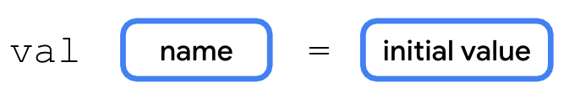

Example
val age = 25
- val is the keyword that tells Kotlin you're creating a variable.
- age is the name of the variable (the label on the box). Is an Identifier
- 25 is the value that the variable holds (the contents of the box).
In simple terms, a variable is just a way to store and keep track of data in your program!

Differences Between val and var.

val (Immutable)
Once you give it a value, you can't change that value anymore. Its like a Fixed Container.
val age = 25
age = 30 // Error! You can't change the value of a val variable

var (Mutable)
You can change the value stored in it as many times as you want.
Its like a Flexible Container.

var age = 25
age = 30 // This is perfectly fine! You can change the value of a var.

Summary
- val: You set the value once, and it cannot be changed.
- var: You can set and change the value as many times as needed.

Working with variables
In Kotlin, when we declare a variable, we don't always need to specify the data type. Instead, we can let the compiler figure it out automatically based on the value we assign to the variable. This is known as type inference. The Data Type is the Type of Data Stored in a variable.

Variable Naming Rules:
- Start with a letter or an underscore: The variable name must start with a letter (a-z or A-Z) or an underscore (_).
- Use letters, numbers, or underscores: After the first character, you can use letters, numbers (0-9), or underscores.
- Cannot use Kotlin keywords: Reserved keywords like fun, val, var, etc., cannot be used as variable names. Check reserved keywords in Appendix A
- Naming conventions: By convention, variables are typically named using camelCase (starting with a lowercase letter and capitalizing subsequent words), e.g., userAge, productPrice, product_price

Example 1: Declaring and initializing Variables
Create a File named Lesson1a.kt and write below code.
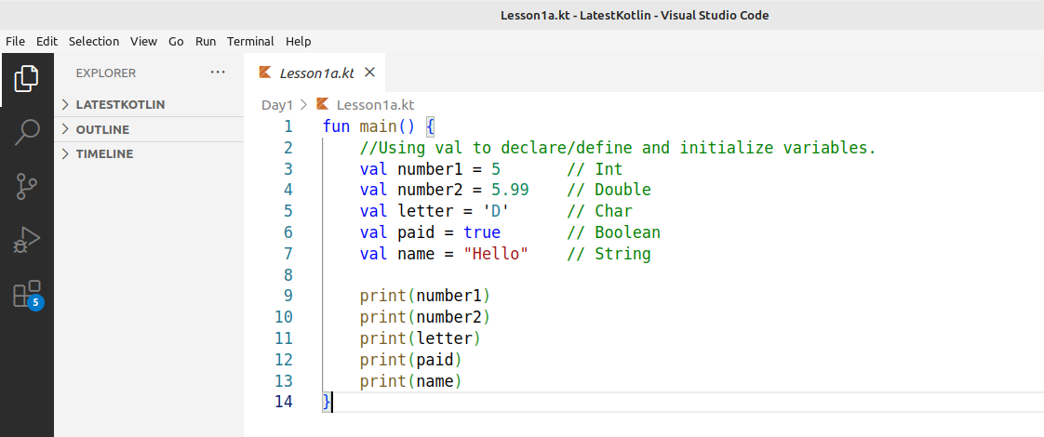

Explanation:
- val number1 = 5: This creates a variable number1 and assigns it the value 5. The Kotlin compiler automatically infers the data type as Int (an integer).
- val number2 = 5.99: This creates a variable number2 and assigns it the value 5.99. The compiler automatically recognizes it as a Double (a number with decimal points).
- val letter = 'D': This creates a variable letter and assigns it the value 'D'. The compiler recognizes it as a Char (a single character).
- val paid = true: This creates a variable paid and assigns it the value true. The compiler recognizes it as a Boolean (either true or false).
- val name = "Hello": This creates a variable name and assigns it the value "Hello". The compiler recognizes it as a String (a sequence of characters).
Printing the Values:
- print(number1): This prints the value of number1, which is 5.
- print(number2): This prints the value of number2, which is 5.99.
- print(letter): This prints the value of letter, which is D.
- print(paid): This prints the value of paid, which is true.
- print(name): This prints the value of name, which is "Hello".

In above example, we leave kotlin to automatically identify the Data Types.

Kotlin Data Types
In the next example we redo Lesson1a.kt example and specify the Data Types.

We look at below Major Data Types,
- Int: Used for whole numbers.
- Double: Used for numbers with decimals.
- Char: Used for a single character.
- Boolean: Used for true/false values.
- String: Used for text (sequence of characters).
Each data type serves a specific purpose, and you use the appropriate type depending on the kind of data you want to store and work with.

Example 2: Variables with Data types
Create Lesson2a.kt and write below code.
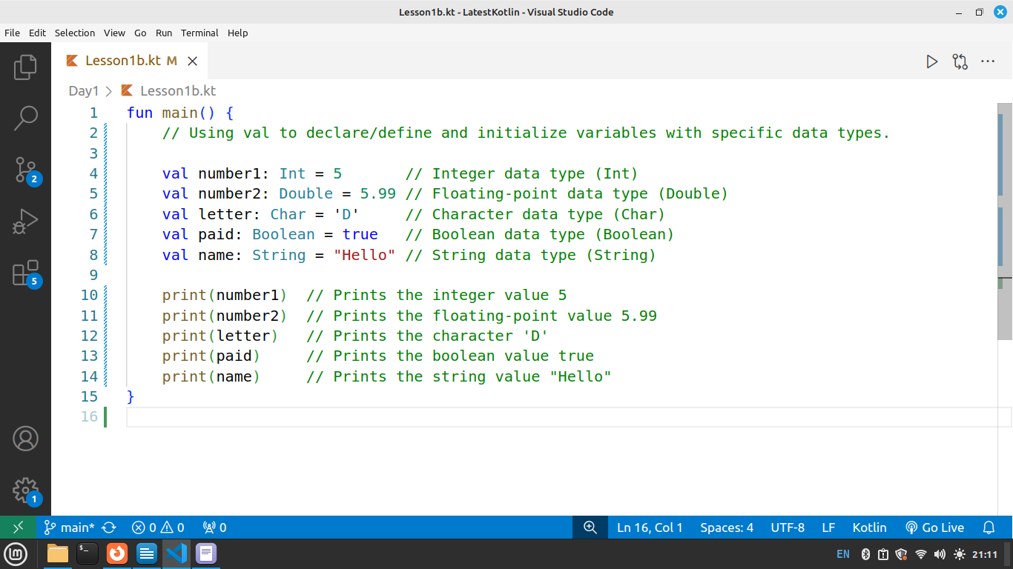

In the Next example, we create a simple calculator using Kotlin variables, First lets look at arithmetic operators to be used in our Calculations.

Arithmetic Operators.
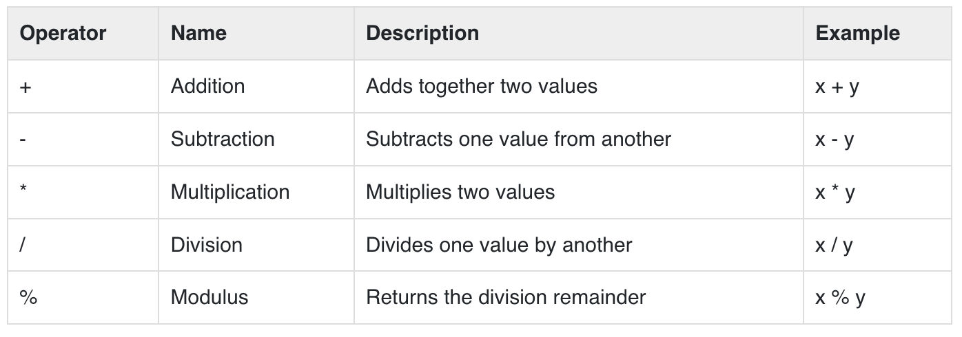

Example 3: Adding 2 Numbers
Create a File named Lesson2c.kt and write below code

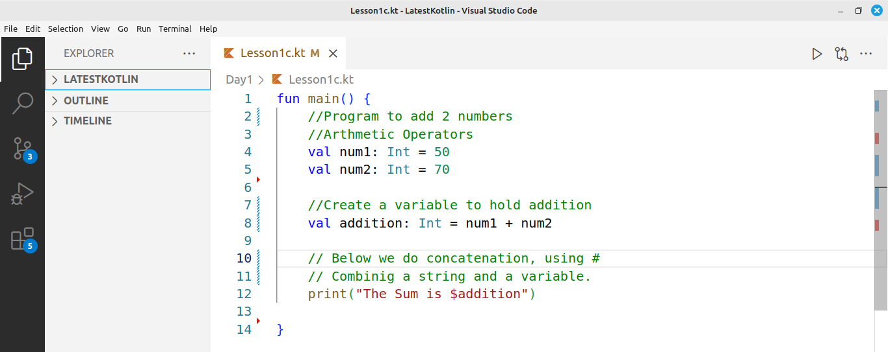
val num1: Int = 50: Declares and initializes an integer variable num1 with the value 50.
val num2: Int = 70: Declares and initializes another integer variable num2 with the value 70.
val addition: Int = num1 + num2: Performs the addition of num1 and num2, stores the result (120) in the variable addition.
print("The Sum is $addition"): Uses string interpolation to combine the string "The Sum is " with the value stored in addition (120) and prints the result.

Assignment
In this assignment, you will build up the code to perform subtraction, division, and multiplication.

Extra Work
In below example we use variables and create a simple interest calculator given Formula PRT/100.
Create a File named prt.kt and write below code.
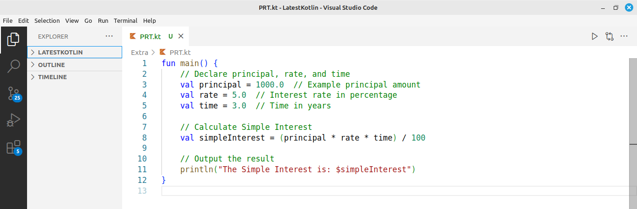

Explanation:
- Creates and stores values in 3 variables namely principal, rate, and time
- The program calculates the interest by multiplying the principal, rate, and time, then dividing by 100.
- Stores the answer in simpleinterest variable
- prints the simpleinterest variable

Practice Assignment: Body Mass Index (BMI) Calculator
Objective: Create a program to calculate the Body Mass Index (BMI) using the formula:
body_mass_index=weight/height * height
Where:
- weight is in kilograms (kg)
- height is in meters (m)

Summary
- Variables store data/values in a program.
- val: Immutable (value can't be changed).
- var: Mutable (value can be changed).
- Int: Whole numbers (e.g., 5, -10).
- Double: Numbers with decimals (e.g., 5.99, -2.5).
- Char: Single characters (e.g., 'A', 'B').
- Boolean: True or false values (e.g., true, false).
- String: Text (e.g., "Hello", "Kotlin").
- Kotlin can automatically detects the data type based on the assigned valu

Chapter 2: Control Statements
In this chapter, we will explore control statements in Kotlin. Control statements allow you to make decisions and repeat actions based on certain conditions. The two primary types of control statements are Conditional Statements and Looping Statements.

Conditional Statements
Conditional statements are used to make decisions based on whether a specific condition is true or false. They allow you to execute certain blocks of code depending on the condition’s result. In Kotlin, there are two common types of conditional statements:

1. if Statement

2. when Statement
First we need to understand Comparison and Logical Operators

Comparison/Relational Operators
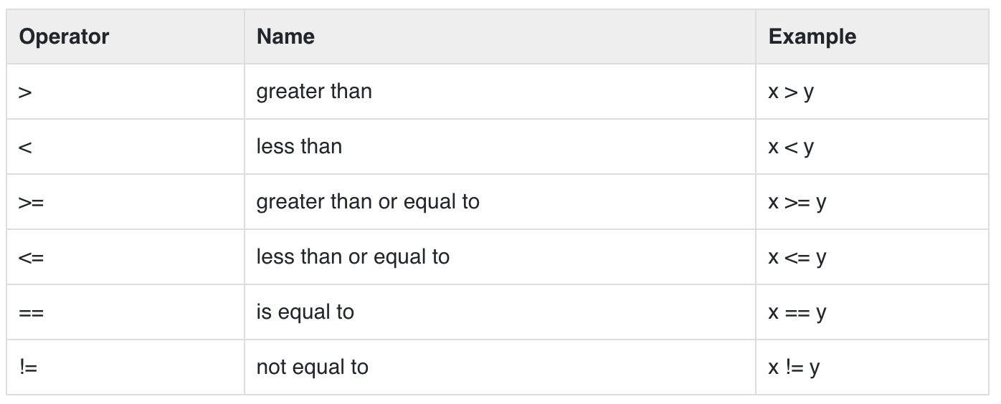

Logical Operators
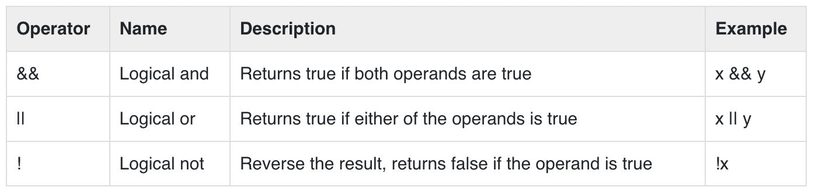
If statement has three statements namely IF, IF ELSE and ELSE IF.

if Statement in Kotlin
The if statement allows you to make decisions based on a condition. If statements runs when the condition is true. Here's the basic syntax

Syntax
if (condition) {
// IF Block/Body Code to execute if condition is true
}

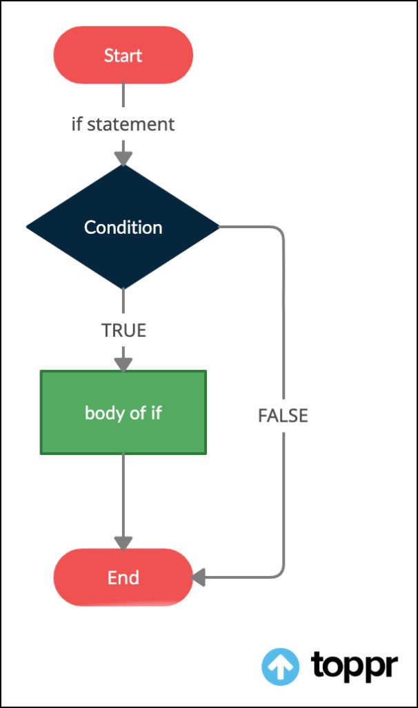
IF - Flow Chart

Example 1
Create a File named Lesson2a.kt and write below code.
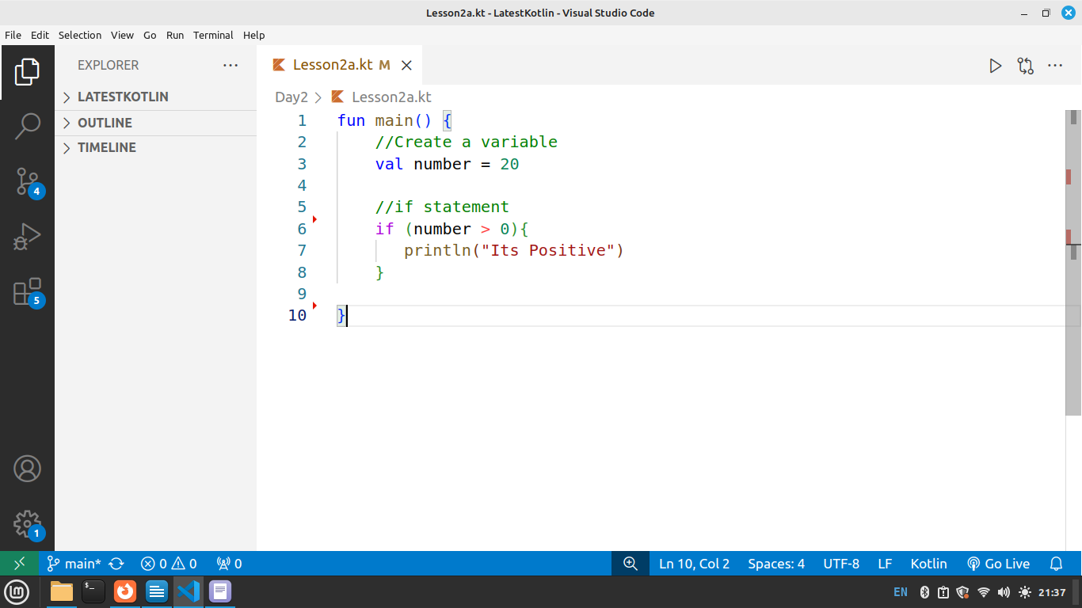

Explanation
- Define a variable number and initialize it to an integer value (20).
- The if statement checks whether the number is greater than zero.
- If the condition (number > 0) is true, the code inside the if block executes.
- If the condition is false, the if statement exits and no further action is taken.

if-Else Statement in Kotlin
The if-else statement allows you to check a condition and execute one block of code if the condition is true, and another block if the condition is false.

Syntax:
if (condition) {
// IF Block/Body Code to execute if condition is true
} else {
// Else Block/Body Code to execute if condition is false
}

IF ELSE Flow Chart

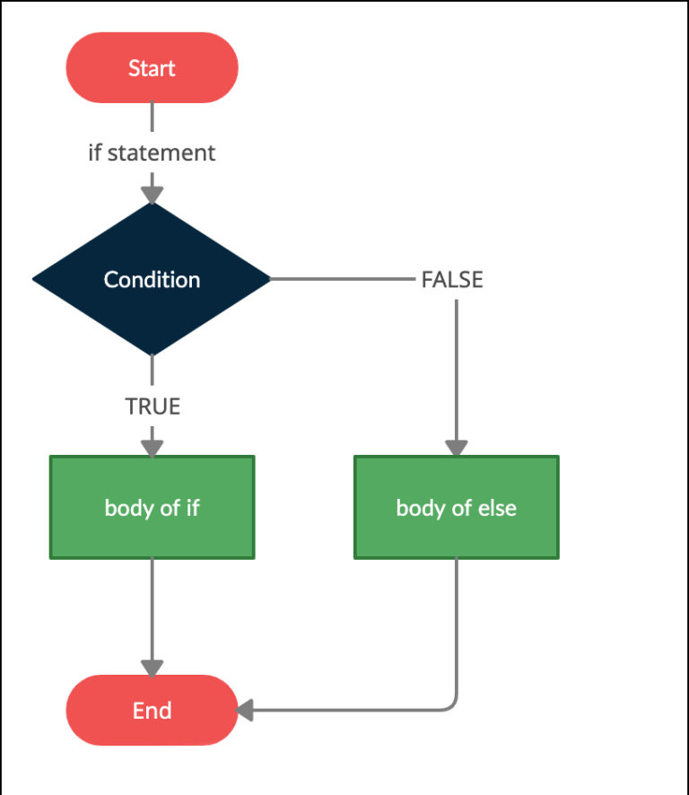

Example 2
Create a File named Lesson2b.kt and write below code.
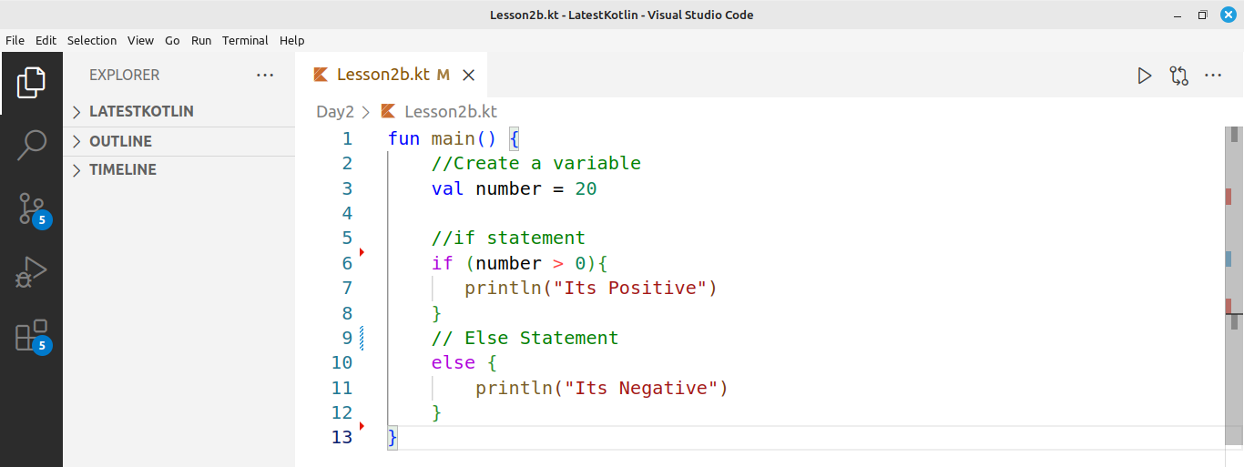

Explanation
if-else statement: Used to make decisions based on a condition.
If the condition is true, the code inside the if block executes.
If the condition is false, the code inside the else block executes.
The if block runs if the condition (number > 0) is true, otherwise the else block runs.

if-Else-if Statement in Kotlin
The if-else-if statement allows you to check multiple conditions in sequence. It evaluates each condition one by one until it finds the first true condition and executes the corresponding block of code.

Syntax
if (condition1) {
// Code to execute if condition1 is true
} else if (condition2) {
// Code to execute if condition2 is true
} else if (condition3) {
// Code to execute if condition3 is true
} else {
// Code to execute if none of the conditions are true
}

IF..ELSE ..IF - Flowchart
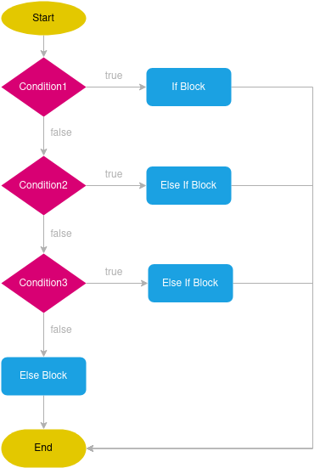

Example 3
Create a File named Lesson2c.kt and write below code.
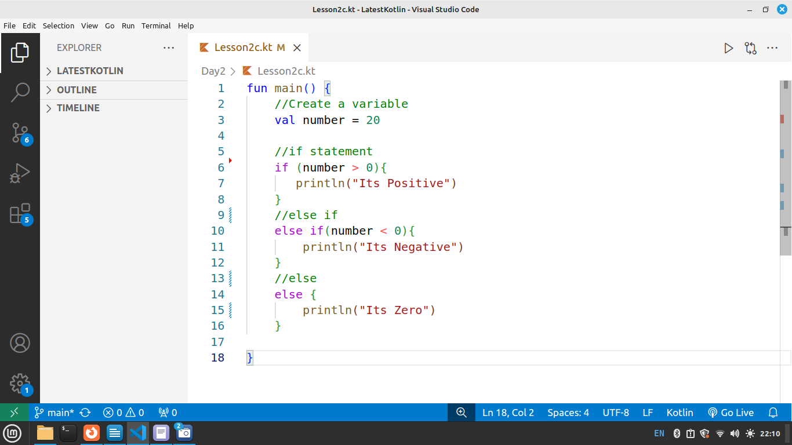

Explanation
- Creates a variable number and assigns it the value 20.
- Checks if number is greater than 0 → Prints "Its Positive".
- If number is less than 0 → Prints "Its Negative".
- If neither condition is met (number is 0) → Prints "Its Zero".
- Uses if-else-if-else to check multiple conditions in sequence.

Example 4
Create a File named Lesson2d.kt and write below code, here we make ue of logical operator && - AND.

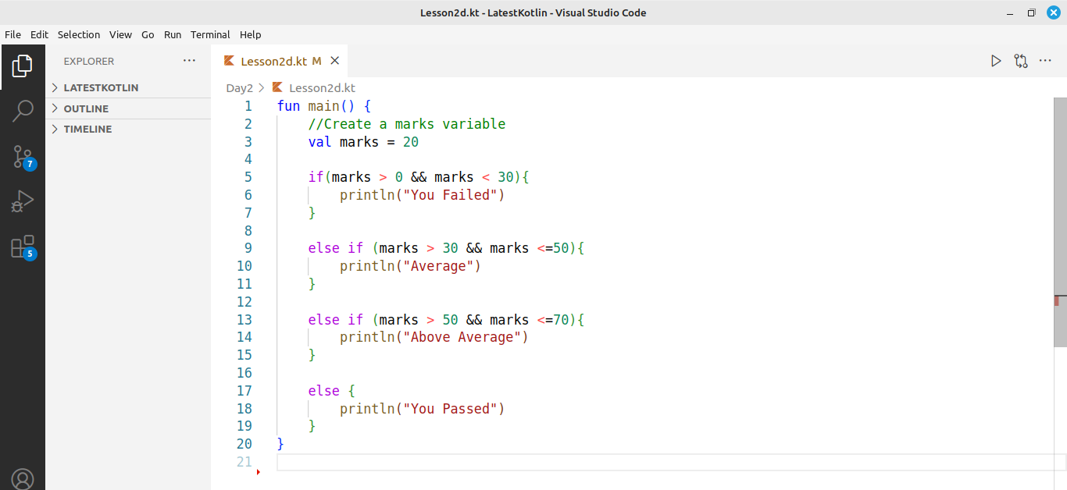

Explanation
- Create a variable marks and assign it the value 20.
- if statement: Checks if marks are between 0 and 30 (not inclusive of 30) → Prints "You Failed".
- else if statements:
- Checks if marks are between 30 and 50 (inclusive of 50) → Prints "Average".
- Checks if marks are between 50 and 70 (inclusive of 70) → Prints "Above Average".
- Final else: If none of the conditions match, it assumes the marks are above 70 → Prints "You Passed".
- && (AND): Combines two conditions, making sure both must be true for the statement to execute

Assignment
Given the table below, Create a Kotlin program to check the price to WIN given the points a customer has acquired

Points | Price to WIN
0 - 100 | You do not qualify
101 – 400 | You Win a Smartphone
401 – 1000 | You win a Laptop
1000 and above | You win a Trip to Canada

The points input cannot be negative.

when Statement
The when statement in Kotlin is like a switch case in other languages. It checks a value against multiple conditions and executes the matching block.

Syntax
when (expression) {
case1 -> // Code to execute if case1 matches
case2 -> // Code to execute if case2 matches
else -> // Code to execute if no cases match
}

Example 5
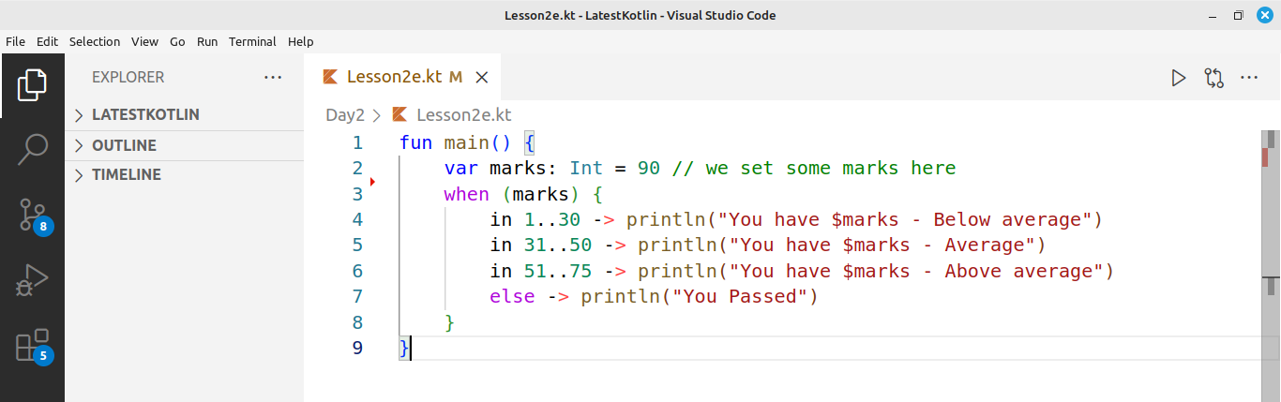

Explanation
- Declares a variable marks with a value of 90.
- when statement checks the range in which marks fall.
- in 1..30 → Prints "Below average".
- in 31..50 → Prints "Average".
- in 51..75 → Prints "Above average".
- else → If marks do not match any range, prints "You Passed".

Practice Assignment
1. Using if statements or when statement, create a program to find if given year is leap or not
2. Using if statements check if a given number is ODD or Even

Summary
- if Statement: Runs a block of code only when the condition is true.
- if-else Statement: Executes one block if the condition is true, otherwise runs the else block.
- if-else-if Statement: Checks multiple conditions in order and executes the first one that is true.
- when Statement: Works like a switch case, matching a value against multiple possible cases.

Chapter 3: Looping/Iterative Statements and Arrays
Looping statements allow us to repeat a block of code multiple times. Kotlin provides different types of loops to handle various scenarios efficiently.
Like other programming languages, Kotlin provides two types of Loops namely;
1. For Loop
2. While Loop

1. for Loop
Used to repeat a Block of code several times. For loop runs a fixed number of times

Syntax
for (variable in range) {
// Code to execute in each iteration
}

For Loop – Flow Chart.

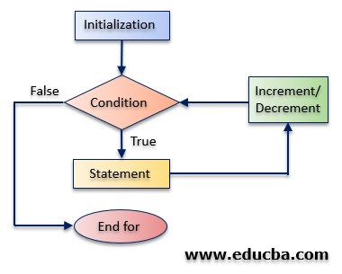

Create a File named Lesson3a.kt and write below for loop code.
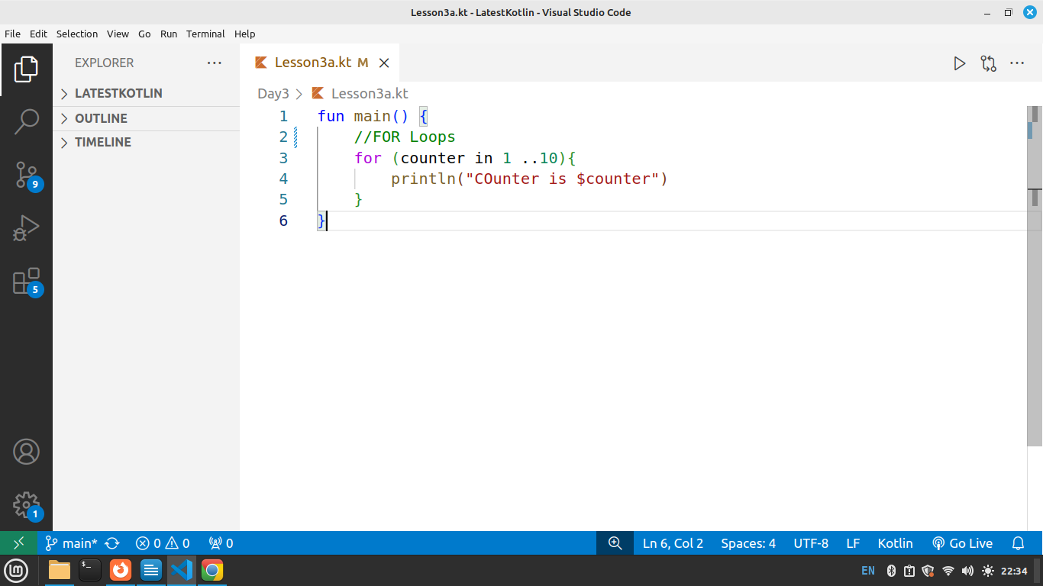

Explanation
- Uses a for loop to repeat code multiple times.
- counter in 1..10 means the loop runs from 1 to 10.
- Each iteration, counter takes the next value in the range.
- Prints "Counter is" followed by the current value of counter.
- Stops after 10, as the loop completes its range.

Assignment
1. Create a For loop to print year from 2000 to 2025
2. Create a For loop to print from 100 to 1

2. while Loop
Executes and repeats a block of code as long as the condition is true.

Syntax
while (condition) {
// Code to execute while the condition is true
}

Create file named Lesson3b.kt and write below code.
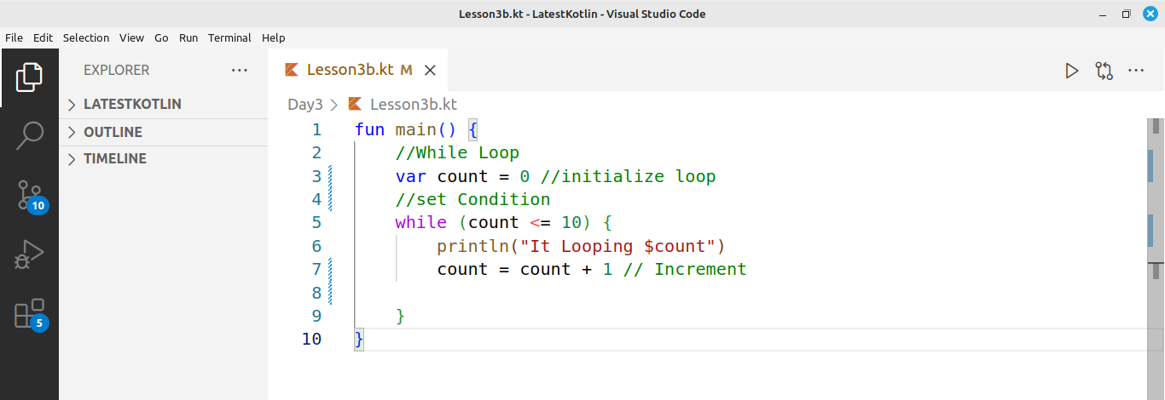

Explanation
- Initializes count to 0 before the loop starts.
- while (count <= 10) checks if count is 10 or less before looping.
- Prints "It Looping" followed by the current value of count.
- Increments count by 1 in each iteration to prevent an infinite loop.
- Stops when count reaches 11, as the condition becomes false.

Assignment
1. Create a while loop to print from -20 to +20
2. Create a while loop to print all EVEN years from 2000 to 2025.

Summary
- Loops are used to run a block of code several times
- There are two types of loops for and while loops
- For Loop: Runs a block of code a set number of times.
- while Loop: Runs as long as the condition remains true.

Introduction to Arrays in Kotlin
An array is a collection of elements of the same data type, stored in a single variable. Arrays allow us to store and manage multiple values efficiently.

Example 1: Creating and Accessing an Array

Create a File named Lesson3c.kt and write below code.
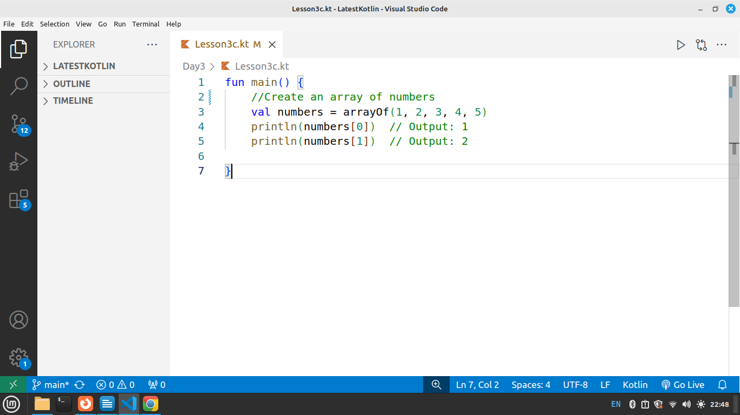

Explanation:
- The arrayOf() function creates an array with elements 1, 2, 3, 4, 5.
- Elements are accessed using an index, starting from 0.
- numbers[0] prints the first element (1), and numbers[1] prints the second element (2).

Example 2: Looping/Iterate Through an Array Using a for Loop

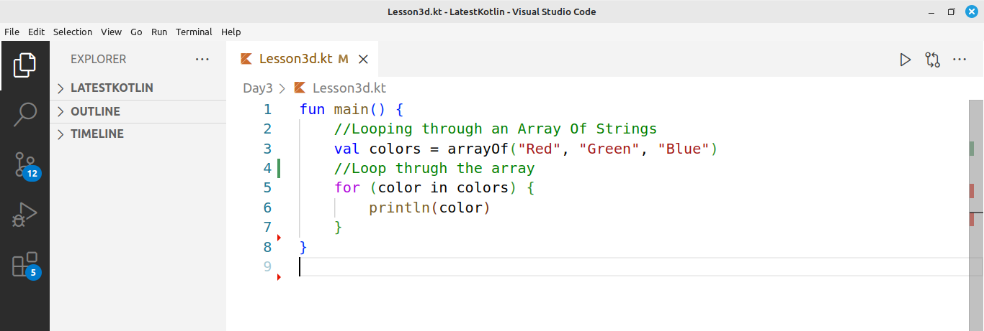

Explanation:
- Defines an array colors with values "Red", "Green", "Blue".
- Uses a for loop to iterate through the array and print each color.

Assignment:
- Create an array of planets (e.g., Mercury, Venus, Earth, etc.).
- Use a loop to print each planet.

Summary
- Array: A collection of elements of the same data type stored in a single variable.
- Accessing Elements: Elements are accessed using an index, starting from 0.
- Creating an Array: Use the arrayOf() function to create an array.
- Looping through Arrays: You can use a for loop to iterate through all elements in the array.
- Benefits: Arrays help store multiple values of the same type, making data management easier.
- Example Usage: Storing lists like numbers, colors, or names in an organized way.

Chapter 4: Functions in Kotlin
A function in Kotlin is a group of statements that are executed together to perform a specific task. Functions help to organize the code, making it reusable, modular, and easy to understand.

Function Definition:
A function is defined using the fun keyword, followed by its name and the block of code (statements) that it performs when called

Syntax
fun functionName() {
// Function body
}

Function Basic Usage.

fun sayHello() {
println("Hello, world!") // Statement 1
println("Welcome to Kotlin!") // Statement 2
}

Calling a Function

A function in Kotlin is Accessed/Called/Invoked using its name. Like below.

sayHello() // Calls the function and executes the statements inside it

Example 1
Create a File named Lesson4a.kt and write below function.
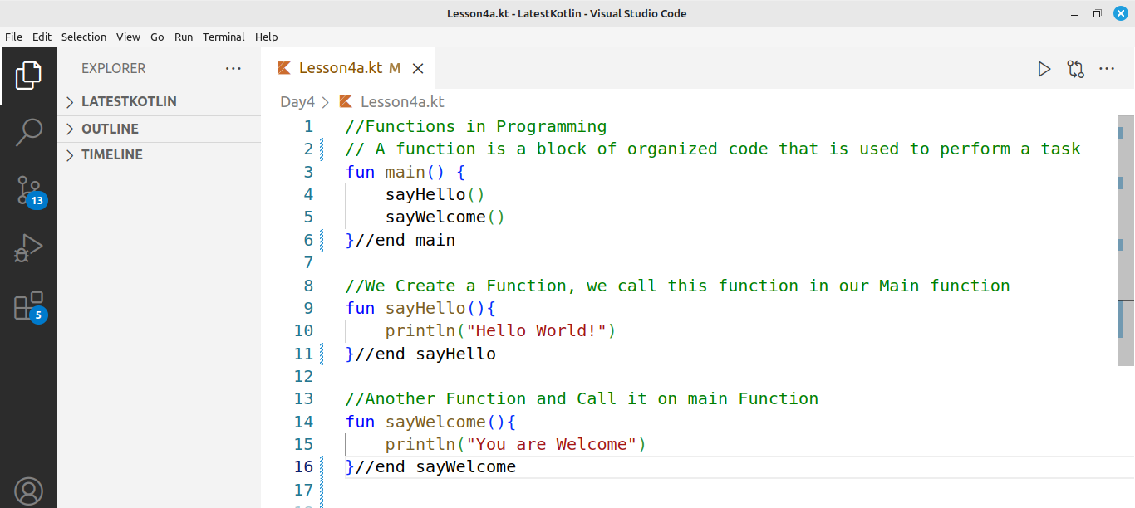

Explanation
- Main Function: The main() function is where the program starts executing.
- sayHello() Function: Prints "Hello World!" when called.
- sayWelcome() Function: Prints "You are Welcome" when called.
- Calling Functions: Inside main(), we call two functions: sayHello() and sayWelcome().
- Reusability: Functions allow us to reuse code, making the program more organized and readable.

Next we create a function to add two numbers and call ut in the main function.

Example 2
Create a file named Lesson4b.kt and write below code.

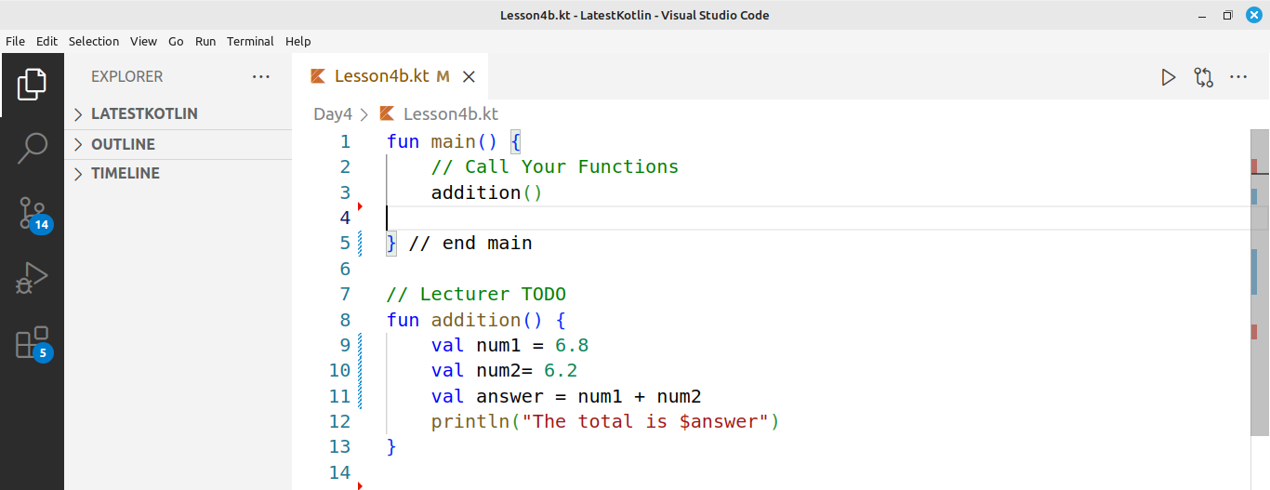

Explanation
- main Function: The main() function calls the addition() function.
- addition() Function: Adds two numbers (6.8 and 6.2) and prints the result.
- num1 and num2 store the numbers to be added.
- answer stores the result of the addition.
- Output: The println() function prints the total (13.0).
- Reusability: The addition() function can be called anytime to perform the addition task.
Assignment: Multiplication/Subtraction Function
a) Create a function in Kotlin that multiplies two numbers and prints the answer.
b) Create a function in Kotlin that subtracts two numbers and prints the answer.

Summary
- A function is a block of code that performs a specific task.
- It is defined using the fun keyword followed by the function name.
- Functions are called by their name followed by parentheses.

Functions with Parameters
Functions can have parameters, which allow them to accept input values and perform tasks based on those inputs. Parameters make functions more flexible and reusable because you can use the same function to work with different data.

Syntax
fun functionName(parameterName: ParameterType) {
// Function body: code to perform the task
}

Explanation
- fun: Keyword to define a function.
- functionName: The name of the function you create.
- parameterName: The name of the parameter inside the function.
- ParameterType: The type of the parameter (e.g., String, Int, Double).
- Function body: Code that defines what the function does using the provided parameter.

Example 3
Create a File named Lesson4c.kt and write below code
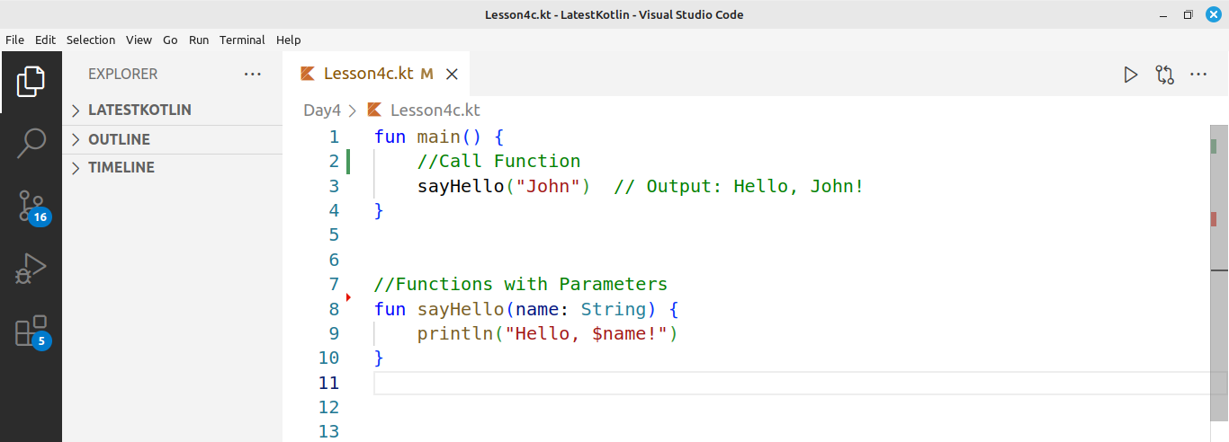

Explanation
sayHello() Function:
- Defined with a parameter name of type String.
- Prints a greeting message with the value passed to the name parameter.
main Function:
- Calls the sayHello() function, passing the argument "John".
- The output is: "Hello, John!".
Purpose:
- This function demonstrates how parameters make a function reusable by allowing it to work with different input values. In this case , we can call the function with different names and it works with new name/data provided.
- The function prints "Hello, John!" when called with "John" as the argument.

Example 4
Create a File named Lesson4c.kt and write below code

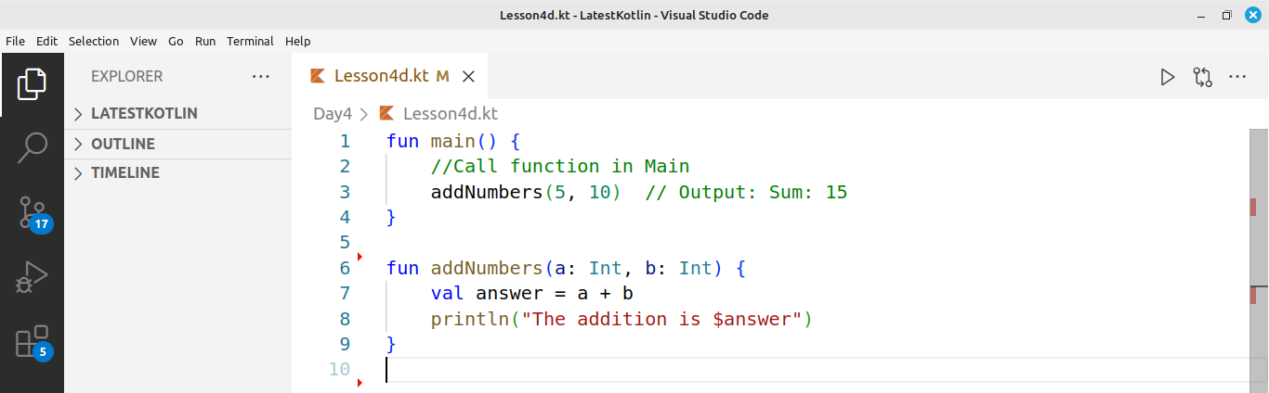

Explanation
- Defined with two parameters: a and b of type Int.
- Adds the two numbers and stores the result in the variable answer.
- Calls the addNumbers() function, passing 5 and 10 as arguments.
- Prints the result with a message: "The addition is $answer".
- The output will be: "The addition is 15".

Assignment
a) Students to do multiplication of 2 numbers.
b) Students to do subtraction of 2 numbers.

Summary
- A function is a block of code that performs a specific task.
- Use fun keyword to create a Function.
- Use function name to call the function
- Functions can accept parameters to work with different data.
- You call a function by using its name followed by parentheses.
- Functions help in reusing code, making the program more organized.
- They improve code readability and maintainability by breaking down tasks.

Chapter 5: Introduction to Object-Oriented Programming (OOP)

What is OOP?
- Object-Oriented Programming (OOP) is a way to organize code using objects. Object oriented has different categories as shown in below image.

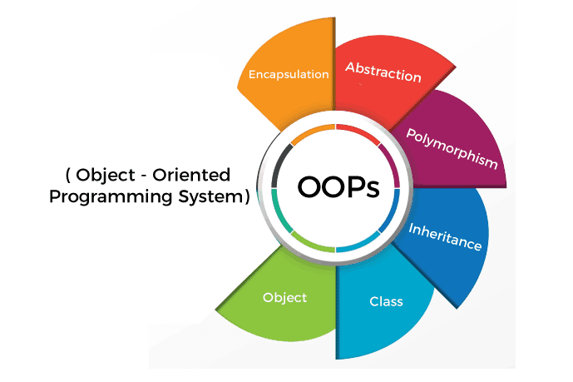

Advantages of Object-Oriented Programming (OOP)
- Modularity:
  - OOP organizes code into classes and objects, making it easier to manage and update parts of the program without affecting others.
- Reusability:
  - Once a class is written, it can be reused in other programs. This reduces redundancy and saves time.
- Scalability:
  - OOP makes it easier to add new features to a program by creating new classes or modifying existing ones without disrupting the entire system.
- Maintainability:
  - Since code is organized into small, self-contained units (objects), it's easier to maintain, debug, and improve over time.

Objects in OOP
- Think of an object as a real-world thing, like a dog. A Dog, Car, Person etc are Objects
- Objects have two key parts, Using example of a Person Object
  - State: The characteristics or attributes of the object (e.g., color, name, age).
  - Behavior: The actions the object can perform or the things it can do (e.g., speak(), walk(), run()).

Relate states and behaviors to Programming;
- State refers to properties/attributes (or attributes) of an object. These are the characteristics that define the object, like age, name, color, height etc
- Behavior refers to functions (or methods) of an object. These are the actions that the object can perform, like running(), walking(), or eating().

Classes in OOP
In Kotlin Object-Oriented Programming (OOP), a class is a blueprint/design for creating objects. It defines properties (variables) and functions that the objects will have.

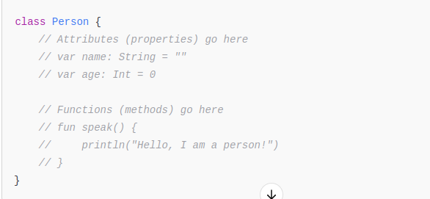
Syntax

The class keyword tells the compiler that we want to create a class. From above, we see that a class contains states/attributes/properties and member functions/methods

Example 1
Create a File named Lesson5a.kt and write below Code.
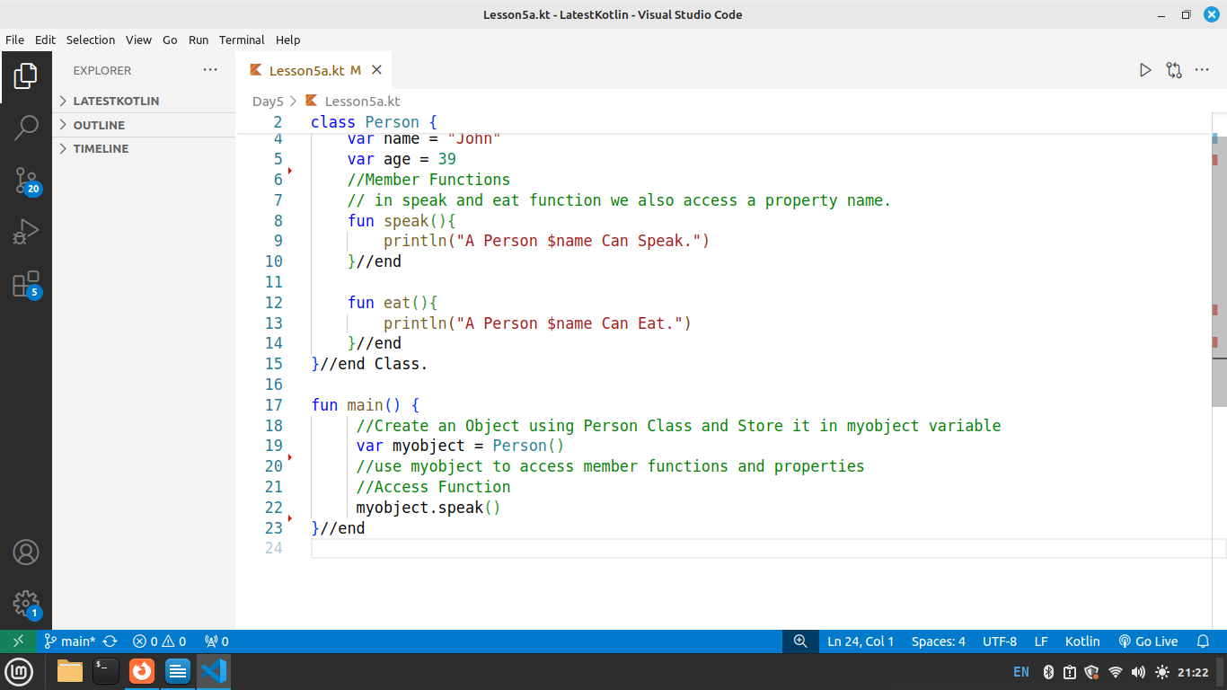

Explanation
- A Person class is created with attributes/properties and methods/functions
- name: A string property initialized with "John".
- age: An integer property initialized with 39.
- speak(): Prints a message that the person can speak.
- eat(): Prints a message that the person can eat.
- The main() function creates an object of the Person class (myobject).
- Calls the speak() function using myobject.

Example 2
In the next example we use OOP design to find the area of Square. Create a File named Lesson5b.kt and write below code.
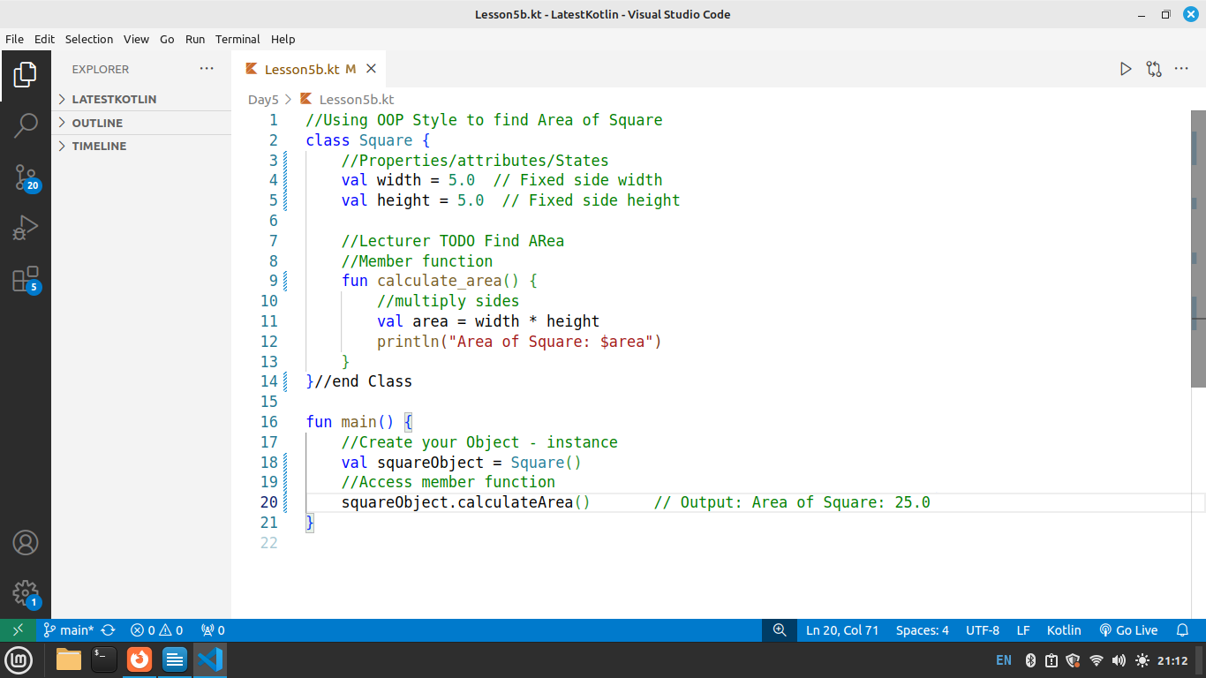

Explanation
- A Square class is created with properties and a function/method.
- width: A fixed property with a value of 5.0.
- height: A fixed property with a value of 5.0.
- calculate_area(): A function/method that calculates the area by multiplying width and height, then prints the result.
- The main() function creates an object of the Square class (squareObject).
- Calls the calculate_area() function using squareObject.

Student Assignment:
Define calculate_perimeter() inside the Square class to correctly calculate and print the perimeter of the square. 🚀
Todo: Add a Function/method to calculate_perimeter() of a Square, Call this function calculate_perimeter() in your main class using the squareObject.

Inheritance in OOP
Inheritance is when one class (child class) gets the properties and functions of another class (parent class).

Example 3
Create a File named Lesson5c.kt and write below code.
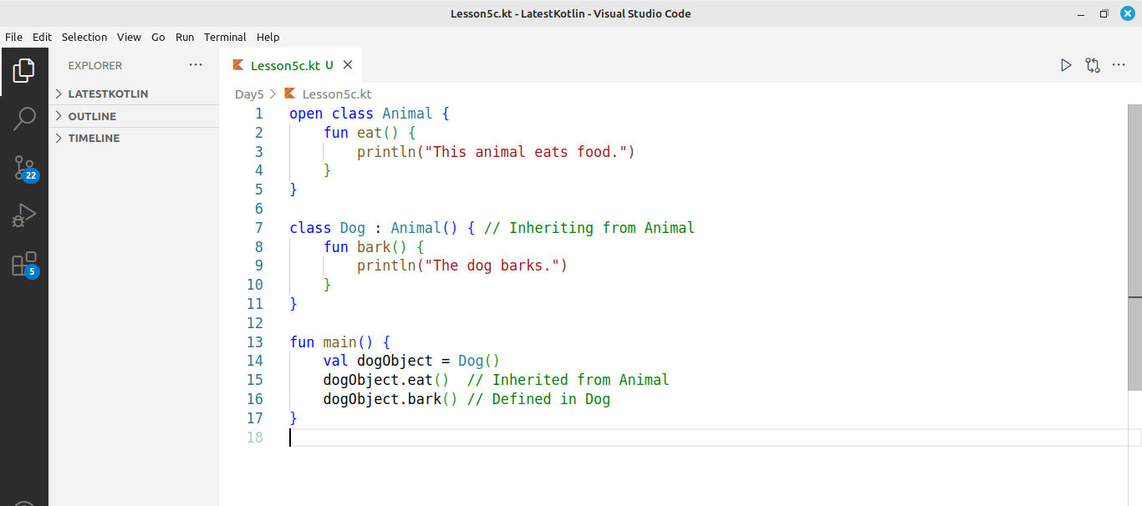
This is inheritance—the Dog gets everything from Animal.

Explanation
- Animal class is created with a function eat().
- Dog class inherits from Animal using : Animal().
- Dog gets access to eat() from Animal.
- Dog has its own function bark().
- In main(), an object of Dog (dogObject) is created.
- dogObject.eat() works because Dog inherits it from Animal.
- dogObject.bark() works because it is defined in Dog.

Chapter 6: Introduction to try, catch, and Exceptions:
In programming, exceptions are errors that occur during the execution of a program. When an error happens, it causes the program to stop, unless we handle it properly.
In Kotlin, we can handle exceptions using the try and catch blocks. The try block contains the code that might cause an error, and the catch block catches and handles that error.

Key Points:
- Exception: An error that occurs during program execution (e.g., dividing by zero, accessing a null value).
- try block: Contains code that might cause an error.
- catch block: Catches and handles the exception if an error occurs in the try block.

Syntax
try {
// Code that might throw an exception
} catch (error: ExceptionType) {
// Code to handle the exception
}

Example 1
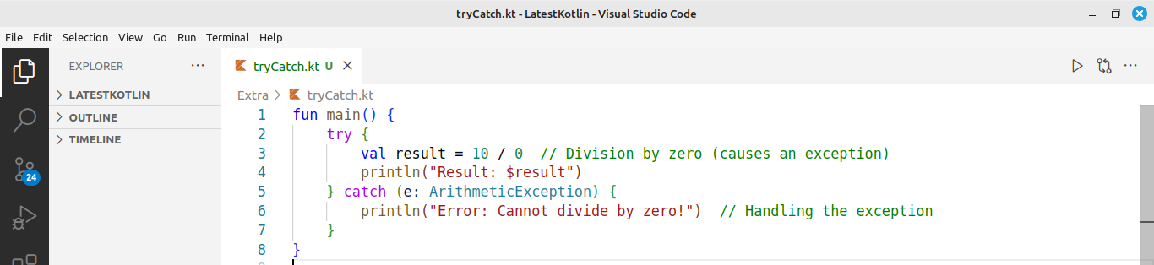

Explanation:
- try block: The division 10 / 0 is inside the try block. This will throw an Exception.
- catch block: The catch block catches the exception and prints a message instead of the program crashing.
- Error Handling: Without try and catch, the program would stop executing when an error occurs. But with exception handling, we can control what happens when an error happens.

Appendix A

Reserved Keywords
These are reserved keywords in Kotlin, and they can't be used as identifiers (variable names, class names, etc.). They serve specific purposes in the language syntax.

Keyword Description
abstract Defines an abstract class or function
assert Used for debugging to assert that a condition is true
break Exits a loop or a when expression
class Defines a class
continue Skips the current iteration of a loop
do Starts a do-while loop
else Defines the else part of an if expression
enum Defines an enum class
false Represents a boolean false value
for Defines a for loop
fun Defines a function
if Starts an if expression
in Used for ranges or checking if an item is in a collection
interface Defines an interface
is Used to check the type of a variable
null Represents a null value
object Defines a singleton or an object declaration
package Defines the package for a class or function
return Exits a function and optionally returns a value
super Refers to the superclass of a class
this Refers to the current instance of a class
throw Used to throw exceptions
true Represents a boolean true value
try Starts a try-catch block for exception handling
val Defines a read-only (immutable) variable
var Defines a mutable variable
when Defines a when expression (similar to switch)
while Starts a while loop

Revision Questions
- What does the main function do in kotlin
- What is the difference between val and var in Kotlin?
- How do you declare a variable in Kotlin
- List any 5 Data types in Kotlin
- Name 5 Arithmetic Operators
- Name any 5 Relational/Comparison Operators
- What is an array in Kotlin.
- How do you declare a function in Kotlin? Provide an example.
- What is the purpose of the fun keyword in Kotlin?
- What is a when expression in Kotlin, and how is it different from a switch statement in other languages?
- What is the purpose of an if statement in Kotlin?
- How do you write an if statement to check whether a number is greater than 10 in Kotlin?
- What is the basic syntax of a for loop in Kotlin?
- How does a while loop work in Kotlin?
- What do you understand by the term Object Oriented
- What is the purpose of a class in Kotlin?
- What is a member function in a Class
- What is inheritance in OOP
- What are exceptions in Kotlin
- Why do we need try and catch in Kotlin
- Declare a variable of type String called greeting and assign it the value "Hello, Kotlin!". Then print the variable.
- Write a Kotlin program that checks if a given number is even or odd using an if-else statement.
- Write a Kotlin function multiply() that takes two integers as parameters and returns their product.
- Write a Kotlin program that tries to access an element outside the bounds of an array and handles the exception using try-catch
- Write a Kotlin program that finds the largest number in an array of integers.
- Write a Kotlin program that prints the numbers from 1 to 10 using a for loop.
- Write a Kotlin program that prints numbers from 10 to 1 in reverse order using a while loop.

References
https://kotlinlang.org/docs/getting-started.html
https://www.w3schools.com/KOTLIN/index.php
https://developer.android.com/courses/pathways/android-development-with-kotlin-1
https://www.tutorialspoint.com/kotlin/index.htm

